class lesson
~/code/inventory
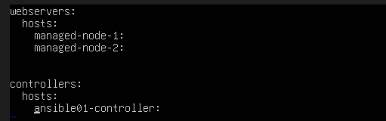
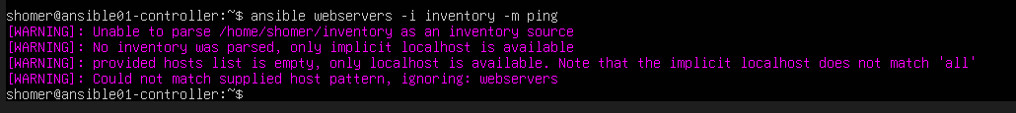
For my lab to function
~/code/inventory.yml
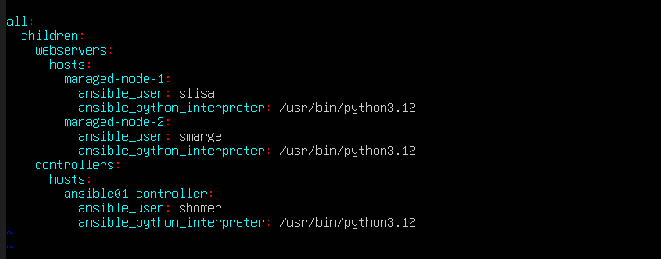
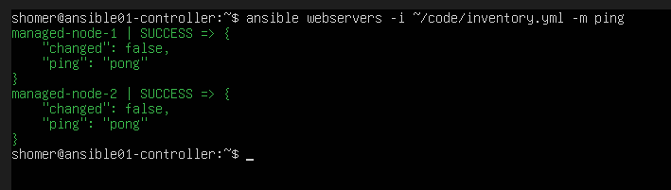
For now I can continue my path learning

